A Project Report on

**Namsate Cab**

Submitted for the partial fulfillment of project in

**Bachelor Of Science (Information Technology) (Semester – V)**

**-: Submitted To: -**



**Department Of Computer Science, Harivandana Collage Rajkot.**

**-: Affiliated To: -**



**Saurashtra University, Rajkot**

**-: Submitted By: -**

**Nandha Aman Y.**

**(Enroll no: 0033042292)**

**-: Under the Guidance of: -**

**Dr. Ashwin Rathod (Professor & Head)**

**Mr. Bhavesh Chavda (Lecturer & Project in charge)**

**Namsate Cab**

Online Cab Booking system and scheduling software save to our user’s time Removing the Bottleneck of Cab Booking system Increased revenue thanks to up selling A modern Approach to Booking Too fast and quickly Booking So People Don’t has to stand in line.

We Will Make More Booking in Less Time

**Preface**

We would like to say that the Projects are very assenting part of our education quota.

We are Pleased to present this project report **on B.Sc(IT)5th Semester** at **HARIVANDANA COLLEGE** it is quite easy to operate for end user. Your feedback is very important to improve our project knowledge.

Once you login to our website you can **Namsate Cab** provided by our **System**

This report contains overview of the whole project. Anyone who is technical person can understand the contact of the system is shown with figures and screens readers can find it easy to understand.

Project report is interesting experience for us. We say it is difficult from particular aspects we come to know about me theoretical ideas of the matter.

By preparing this report we have understand the need of particular training in the education field it is easier to work with **computerized system.**

**Acknowledgement**

We take great pleasure in presenting this project done in the 5th semester of **Bachelor of Science (Information Technology)**. we would like to mention here that this project would not have been possible without the invaluable support and guidance of our professors.

As the final frontier toward achieving a **Bachelor of Science (Information Technology)**. the activity of going through IT project has bridge the gap between the academic and practical real-life work for us. It has prepared us to apply ourselves to become good IT professional.

On the even of completion of our project regarding Online Cab Booking **.** We would like to express our gratitude to the following individuals.

We are extremely grateful to them who were helped us. We would like to give our special thanks to **Mr. Bhavesh Chavda** for stimulating discussion & Suggestions.

It has been rich and rewarding experience studying at **HARIVANDANA COLLEGE**

**INDEX**

|  |  |  |
| --- | --- | --- |
| **No** | **Title** | **Page No.** |
| **1** | **Introduction of Project**   * Admin Side * Client Side | **6** |
| **2** | **Project Profile** | **7** |
| **3** | **Technology study**   * About Frontend * About Backend | **8** |
| **4** | **Time Line Chart**   * Preliminary Investigation * System Analysis * System Design * System Development * Testing * Improvement * Final Testing | **14** |
| **5** | **SDLC Stage wise Implementation**   * Preliminary Investigation * Economical Physibility * Operational Physibility | **16** |
| **6** | **Data Dictionary**  **Namsate Cab**   * Admin * Cab catalogue * Customer * Contact us | **18** |
| **7** | **Data Flow Diagram**   * **Both Side** * User Case * Client-Side User Case * Admin Side User Case * **DFD Diagram** * DFD 0 Level * DFD Level 1 Client Side | **23** |
| **8** | **Screenshot** | **31** |
| **9** | **System Testing**   * White Box Testing * Black Box Testing * Grey Box Testing * Manual Testing * Automation Testing | **44** |
| **10** | **Advantages & limitations of project** | **47** |
| **11** | **Future Enhancement** | **48** |
| **12** | **References** | **49** |

**Introduction of Project:**

Welcome to Namaste Cab, where your journey is our priority! We aim to transform the way you travel by providing safe, reliable, and eco-friendly transportation options tailored to your needs. Our user-friendly app makes booking a cab quick and hassle-free: simply enter your pickup and drop-off locations, and our dedicated drivers will be on their way to assist you. With features like real-time tracking, multiple payment options, and timely ride updates, you can enjoy a seamless travel experience from start to finish.

Whether you're heading to a business meeting, catching a flight, or enjoying a night out, Namaste Cab ensures you reach your destination safely and on time. We pride ourselves on our commitment to customer satisfaction and sustainability, integrating electric and hybrid vehicles into our fleet. Join us in redefining travel with a service that combines comfort, safety, and environmental consciousness—book your ride today and let us take you where you need to go!

* The Project Namsate Cab has been developed on HTML, PHP, CSS, JavaScript, Bootstrap and MySQL.
* The Web Portal will have an online interface in the form of an Ecommerce Website that will allow users to see details form the Cab.
* There are two types of users available in the Project.

1. Client Side
2. Admin Side

* First one is **Client** and second one is **Admin**.
* Clients or users have limited access right to access the system while the admin users have control over the system.
* MySQL as a Database,
* HTML for Structure Designing,
* CSS for Web Page formatting,
* JavaScript form Validation and Animation.
* I have also attached the project screens of this project look into it.

**Project profile:**

**Project Title** : “Namsate Cab”

**Hardware Used** : 8.00 GB RAM 64-bit operating system

**Operating System** : Windows-11

**Front End** : HTML, CSS, BOOTSTRAP, JS

**Back End** : PHP, MYSQL

**Documentation Tools** : Microsoft Word

**Project Guide** : Mr. Bhavesh Chavda

**Project Duration** : 3 Months

**Prepared By** : Aman Nandha

**Submitted To.** : Saurashtra University, Rajkot.

**Technology study**

* **About frontend**
* **HTML: -**

HTML is computer language devised to allow Website creation. This website can then be viewed by anyone else connected to internet. It is relatively **easy to learn** with the basic being accessible to most people in one sitting and quite **powerful** in what it allow you to create. It is constantly undergoing revision and evaluation to meet demand and requirement of the growing. Internet audience under the direction of the W3c, the organization charged with designing.

* **HTML is the standard markup language for creating web pages.**
* HTML stands for Hypertext Markup language.
* **HTML describes the structure of web pages using markup.**
* HTML elements are the building blocks of HTML pages.
* **HTML elements are represented by tags**.
* HTML tags label pieces of content such as “Heading”, “Paragraph”, “Table” and so on.
* **JAVASCRIPT: -**

Java script file is used mainly to run client-side Java script code on webpage and its extension is .js.

The .js file contains all the HTML HEAD and BODY objects in the tags of on HTML page.

Java script is used in web Development to do such things are: -

• Automatically change a formatted date.

• cause a linked-to-page to pop up in a new Window.

• cause text or image to change during a Mouse rollover.

Despite the name JavaScript is essentially underlated to java programming. Through both have the common (syntax and JavaScript) copies many java names and naming conventions.

The language was renamed from Live Script in co-marketing deal between Netscape and sun in exchange for Netscape bundling sun’s java runtime with their browser.

The key design principles within JavaScript’s are inherited from the self-programming language.

* **CSS:**

**What is CSS?**

* CSS stands for Cascading Style Sheets
* CSS describes how HTML elements are to be displayed on screen, paper, or in other media
* CSS saves a lot of work. It can control the layout of multiple web pages all at once
* External stylesheets are stored in CSS files

**BOOTSTRAP:**

**WHAT IS BOOTSTRAP?**

**Bootstrap** is the most popular **CSS Framework** for developing responsive and mobile-first websites.

**Bootstrap 5** is the newest version of Bootstrap.

**About Backend: -**

* **MYSQL: -**

**What is Database?**

Database is separate application that store collection of data.

Each database has one or more distinct APIs for creating, accessing, managing, searching and replicating the data it holds.

* **What is RDBMS?**

We use Relational database management Systems (**RDBMS**) to store and manage huge volume of data.

This is called relation because all the data is stored into different tables and relations are established using primary key.

* **MYSQL Database: -**

MYSQL is fast, easy to use RDBMS being used for many small and big business. MYSQL is developed, market and supported by MYSQL becoming so popular because of many good reasons:-

It is released under on open-source license. So, you have nothing to pay to use it.

It is very powerful program in its own right. it handles a large subset of the functionality of the most expensive database package.

It uses standard form of the well-known SQL data language.

It works on many operating system and with many languages including PHP, PERL, C, C++, JAVA etc………

It works quickly and work well even with large data sets.

It supports large database, up to so million rows or more in table.

The default file size limit for table is 4GB but you can increase this (**is your operating system can handle it**) to a theoretical limit of 8 million Tera-bytes (**TB**).

It is customizable. The open-source GPL license allows programmers to modify the MYSQL software to fit their own specific environments.

MYSQL, the most popular open-source **SQL** database management system is developed, distributed and supported by **MYSQL AB**.

MYSQL AB is commercial company, founded by the **MYSQL** developers.

* **What is PHP?**

PHP is a server-side scripting language designed for web development but also used as a general-purpose programming language. PHP is now installed on more than 244 million websites and 2.1 million web servers. Originally created by Rasmus Lerdorf in 1995, the reference implementation of PHP is now produced by The PHP Group. While PHP originally stood for Personal Home Page, it is now said to stand for PHP: Hypertext Preprocessor, a recursive acronym.

* **What is a PHP File?**
* PHP files can contain text, HTML, JavaScript code, and PHP code.
* PHP code are executed on the server, and the result is returned to the browser as plain HTML.
* PHP files have a default file extension of ".php".
* **What Can PHP Do?**
* PHP can generate dynamic page content.
* PHP can create, open, read, write, and close files on the server.
* PHP can collect form data.
* PHP can send and receive cookies.
* PHP can add, delete, modify data in your database.
* PHP can restrict users to access some pages on your website.
* PHP can encrypt data.

With PHP you are not limited to output HTML. You can output images, PDF files, and even Flash movies. You can also output any text, such as XHTML and XML.

* **Why PHP?**

* PHP runs on different platforms (Windows, Linux, Unix, Mac OS X, etc.).
* PHP is compatible with almost all servers used today (Apache, IIS, etc.).
* PHP has support for a wide range of databases.
* PHP is free. Download it from the official PHP resource: www.php.net.
* PHP is easy to learn and runs efficiently on the server side.

**TIME LINE CHART**

|  |  |  |  |  |
| --- | --- | --- | --- | --- |
| **TASK**  **NO.** | **TASK NAME** | **START DATE** | **END DATE** | **DURATION** |
| 1 | Preliminary Investigation | 7-7-24 | 17-7-24 | 10 days |
| 2 | System Analysis | 18-7-24 | 25-7-24 | 8 days |
| 3 | System Design | 26-7-24 | 9-8-24 | 15 days |
| 4 | System Development | 10-8-24 | 27-8-24 | 18 days |
| 5 | Testing | 28-8-24 | 2-9-24 | 5 days |
| 6 | Improvement | 3-9-24 | 10-9-24 | 6 days |
| 7 | Final Testing | 11-9-24 | 19-9-24 | 6 days |

**SDLC Stage wise Implementation**

**1. Preliminary Investigation: -**

**Information Gathering:**

For getting Information of Namsate Cab we can use Google Web Site. Also we have gathered extra Information by Our College Library and our guide Mr. Bhavesh Chavda.

**Requirement Analysis:**

Requirement Analysis is critical to the success or failure of system or software project. For this we need to different Physibility study.

**Physibility Study: -**

**(1). Technical Physibility:**

This Page Gives Technical Information About used hardware and software and software in our project.

**1. Editor** : Notepad/Notepad++/Visual Studio Code etc

**2. Browser :** Internetexplorer

**3.** **Servers** : Apache

**4. Backend :** mysql, php

**5. Frontend :** Html, CSS, JS, bootstrap

**6. RAM :** 8.00 GB (7.37 GB usable)

**7. Hard disk:** 64-bit operating system, x64-based processor

**8. Processor:** AMD Ryzen 5 4600H with Radeon Graphics 3.00 GHz

**9. Screen :** 17Inches

**10. Devices :** Keyboard, Mouse

**(2). Economical Physibility:**

* It is evaluating the effectiveness of candidate system by using cost/benefit analysis method.
* It demonstrates the net benefit from the candidate system in terms of benefits and costs to the organization.
* The main aim of Economic Feasibility Analysis (EFS) is to estimate the economic requirements of candidate system before investments funds are committed to proposal.
* It prefers the alternative which will maximize the net worth of organization by earliest and highest return of funds along with lowest level of risk involved in developing the candidate system.

**(3). Operational Physibility:**

**Request Approval: -**

Analysis approved the demands of user and ready to develop the project.

We can gone through the Investigation process and Ready/agree to develop this project.

**2. System Analysis: -**

**\* Manual System**

In Manual system we need to explain the Namsate Cab of Information.

We need remember the any Information about the Namsate Cab

**\* Proposed System**

In proposed System any Visitors visit to our web site.

Reduce the workload of employee.

All details will be available on a click.

**3. System Design**

**Data Dictionary**

Data Dictionary is set of information describing the contents, format and structure of database and the relationship between its elements, used to control access to and manipulation of the database.

Designer selects file structure and storage devices.

**User:**

|  |  |  |
| --- | --- | --- |
| **Field name** | **Data Type** | **Size** |
| id (AI) | Int | 50 |
| uname | Varchar | 50 |
| password | Varchar | 50 |

**Categories:**

|  |  |  |
| --- | --- | --- |
| **Field name** | **Data Type** | **Size** |
| id (AI) | Int | 100 |
| cname | Varchar | 200 |
| catdescription | Text | - |
| image | Varchar | 200 |
| status | Int | 11 |
| last_update | Timestamp | - |

**Subcategories:**

|  |  |  |
| --- | --- | --- |
| **Field name** | **Data Type** | **Size** |
| id (AI) | Int | 100 |
| catid | Int | 5 |
| subcname | Varchar | 200 |
| subcatdescription | Text | - |
| image | Varchar | 200 |
| status | Int | 11 |
| last_update | Timestamp | - |
| price | bigint | 20 |

**Pickup_drop:**

|  |  |  |
| --- | --- | --- |
| **Field name** | **Data Type** | **Size** |
| id (AI) | Int | 11 |
| name | Text | - |
| email | Varchar | 255 |
| phone | bigint | 20 |
| car | text | - |
| Pickup_location | text | - |
| Drop_location | text | - |
| Pickup_date | date | - |
| Return_date | date | - |
| status | int | 11 |
| last_update | Timestamp | - |

**Contact_us:**

|  |  |  |
| --- | --- | --- |
| **Field name** | **Data Type** | **Size** |
| id (AI) | Int | 11 |
| name | Varchar | 255 |
| email | Text | - |
| phone | bigint | 20 |
| message | longtext | - |
| status | Int | 11 |
| last_update | Timestamp | - |

**blog:**

|  |  |  |
| --- | --- | --- |
| **Field name** | **Data Type** | **Size** |
| id (AI) | Int | 11 |
| date | date | - |
| title | mediumtext | - |
| image | text | - |
| description | longtext | - |
| status | Int | 11 |
| last_update | Timestamp | - |

**About_us:**

|  |  |  |
| --- | --- | --- |
| **Field name** | **Data Type** | **Size** |
| id (AI) | Int | 11 |
| About_title | mediumtext | - |
| image | Text | - |
| About_description | longtext | - |
| status | Int | 11 |
| last_update | Timestamp | - |

**Register:**

|  |  |  |
| --- | --- | --- |
| **Field name** | **Data Type** | **Size** |
| id (AI) | Int | 20 |
| username | Varchar | 300 |
| password | Varchar | 100 |
| email | varchar | 100 |

**Payment:**

|  |  |  |
| --- | --- | --- |
| **Field name** | **Data Type** | **Size** |
| id (AI) | Int | 100 |
| Payment_method | Int | 50 |
| name_on_card | Int | 100 |
| Card_number | Int | 20 |
| Exp_month | Int | 2 |
| Exp_year | varchar | 4 |
| cvv | varchar | 4 |
| Paypal_email | varchar | 100 |
| Accout_number | varchar | 20 |
| Bank_number | varchar | 100 |
| Created_at | Timestamp | - |

**Data Flow Diagram: -**

It is Graphical representation of the “flow” of data through an information system, modeling its process aspect.

The DFD is also known as bubble chart where user processing carried out on this data, and the output data generated by the system.

The main reason DFD technique is so popular is on the account of the fact. That it is very simple formulism it is simple to use and understand.

It can be used for the visualization of data processing.

It shows what kind of information will be input to and output from the system, how the data will advance through the system and where the data will be stared.

It does not show information about process timing or whether processor will operate in sequence or in parallel, unlike a traditional structured flow chart which focus on control flow, or UML activity workflow diagram, which presents both control and data, flows as an unfiled model.

**Following symbols are use in DFD:**

|  |  |  |
| --- | --- | --- |
| **Symbol** | **Name** | **description** |
|  | Arrows | The flow of data between data star external entities and process. |
|  | Circles | A process manipulates data and representation graphical as a circle rectangle will round edge. |
|  | Open-ended box | Data store where data is held temporary or prenatally. |
|  | Square | External entities such as people or other systems that feed data to data from the system, remove the person from the box. |

**• DFD:-**

* **CONTEXT LEVEL DFD:-**

**(0 Level Diagram)**

**Book Cab**

**Log in**

* **CONTEXT LEVEL DFD:-**

**(1 Level Diagram)**

**Logout**

**Database**

**Register**

**Login**

**User**

**Registration**

**All Data**

**Login**

* **DFD Level 1 (Diagram)**

**Admin Side**

**Payment**

**Book Cab**

**Edit Category**

**Add Category**

**Log in**

**Edit**

**Home**

**Delete Category**

**Use Case Diagram:-**

**Client Side Use Case**

**Log in**

**Database**

**Cars**

**Category**

USER

**About us**

**Blog**

**Admin Side Use Case**

* **Here Admin can view, add, delete, update Cab images, title, description detail etc.**

**Database**

**Delete**

**Edit**

**Add**

**Admin**

**Activity Diagram:-**

Select Category

Home

Check

Login

**SCREEN SHOTS OF PROJECT**



**LOGIN PAGE**

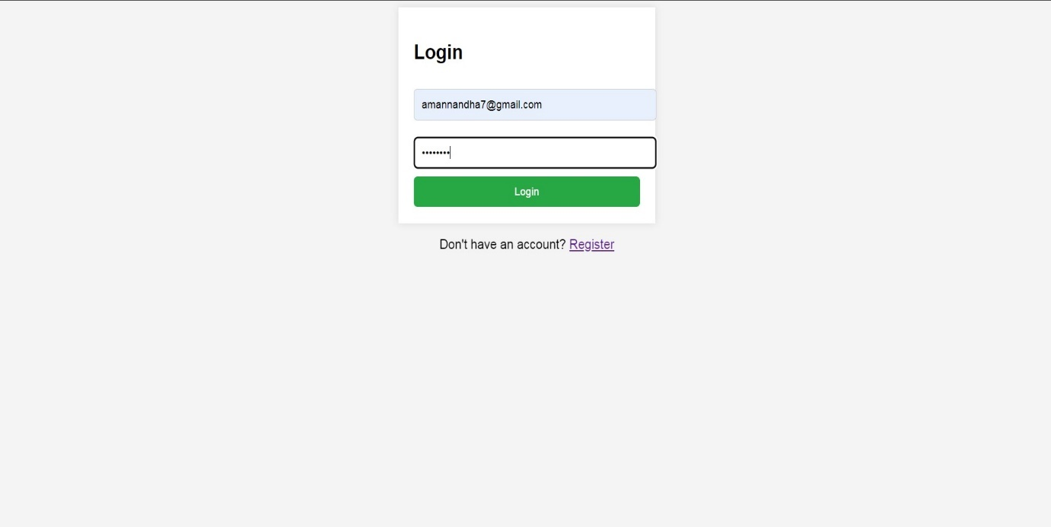

**USER REGISTER PAGE**

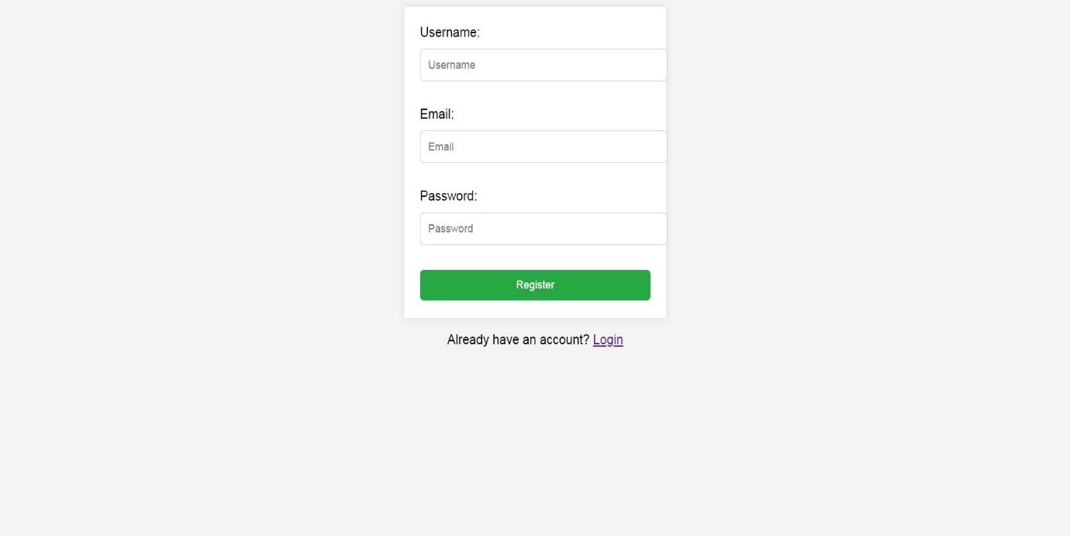

**USER HOME PAGE**

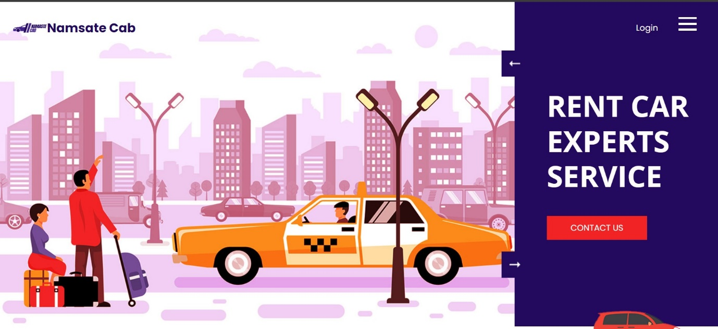

**CAB BOOKING SCREEN**

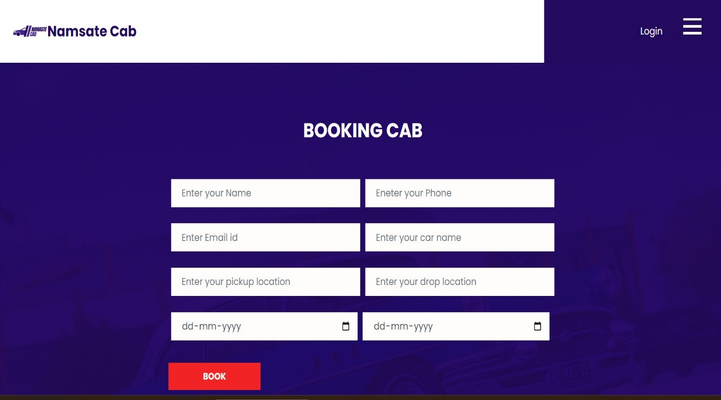

**MY CAB BOOKING SCREEN**

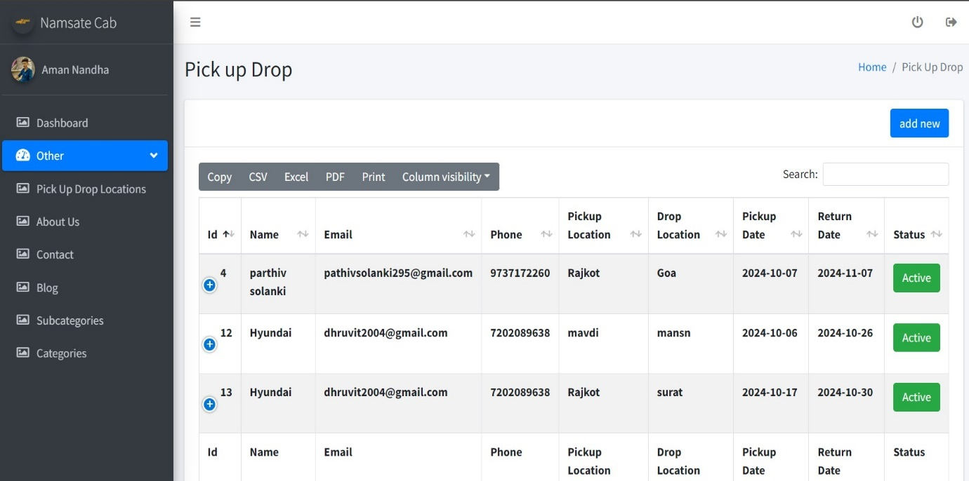

**ABOUT PAGE**

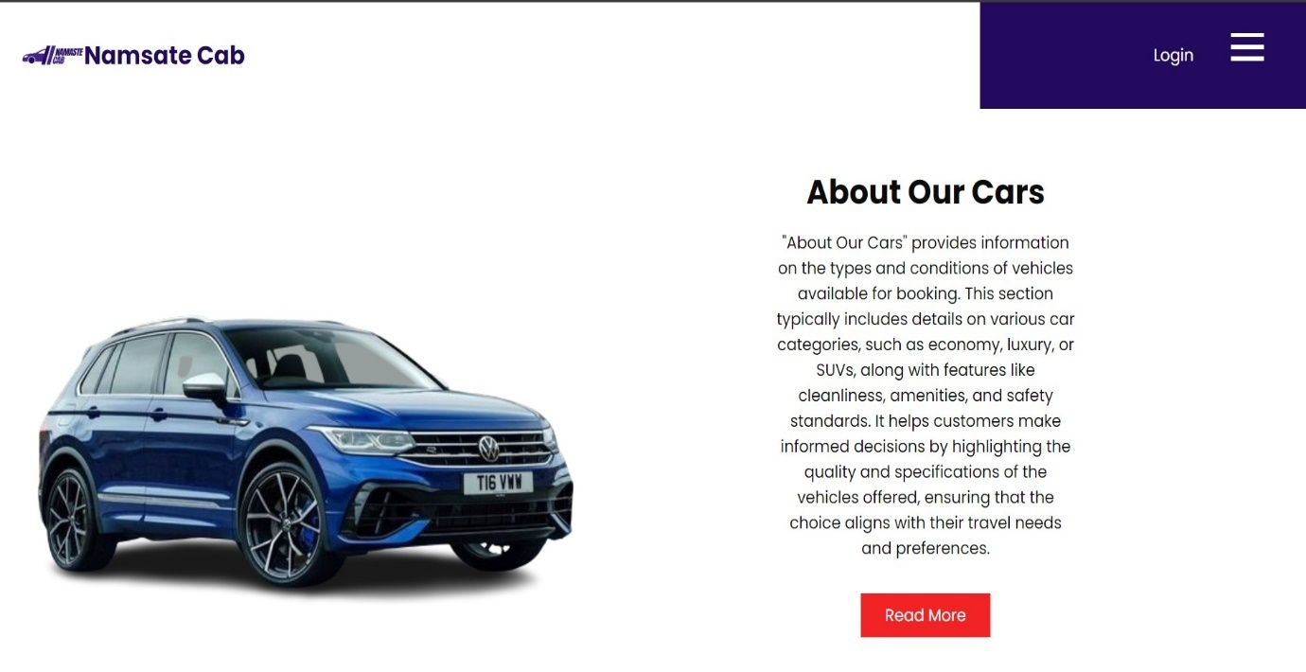

**ADMIN PANEL SIGN IN PAGE**

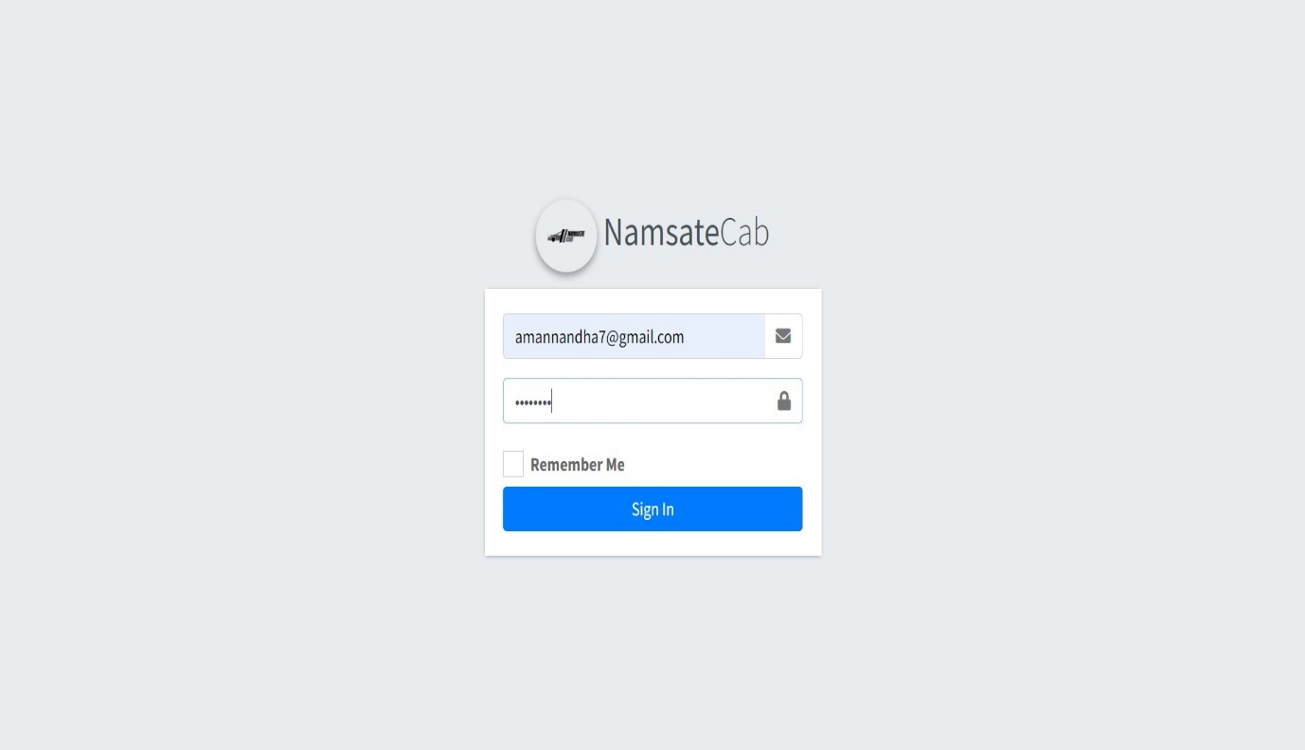

**ADMIN HOME SCREEN**

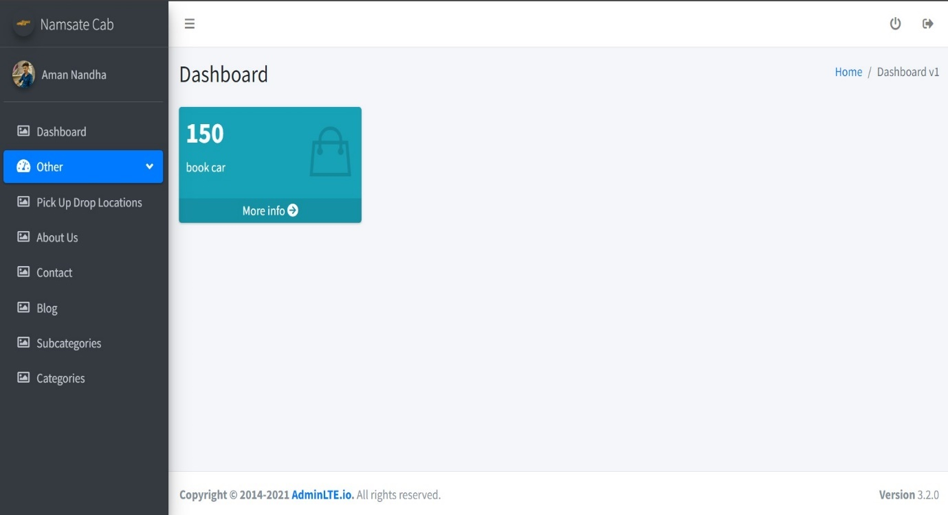

**ADMIN CAB CATEGORIES**

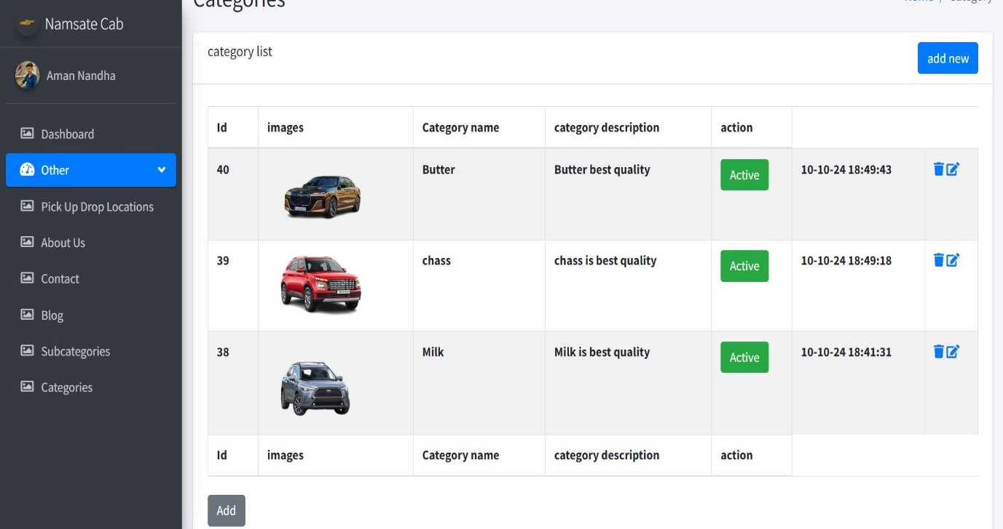

**ADMIN SUB CATEGORIES SCREEN**

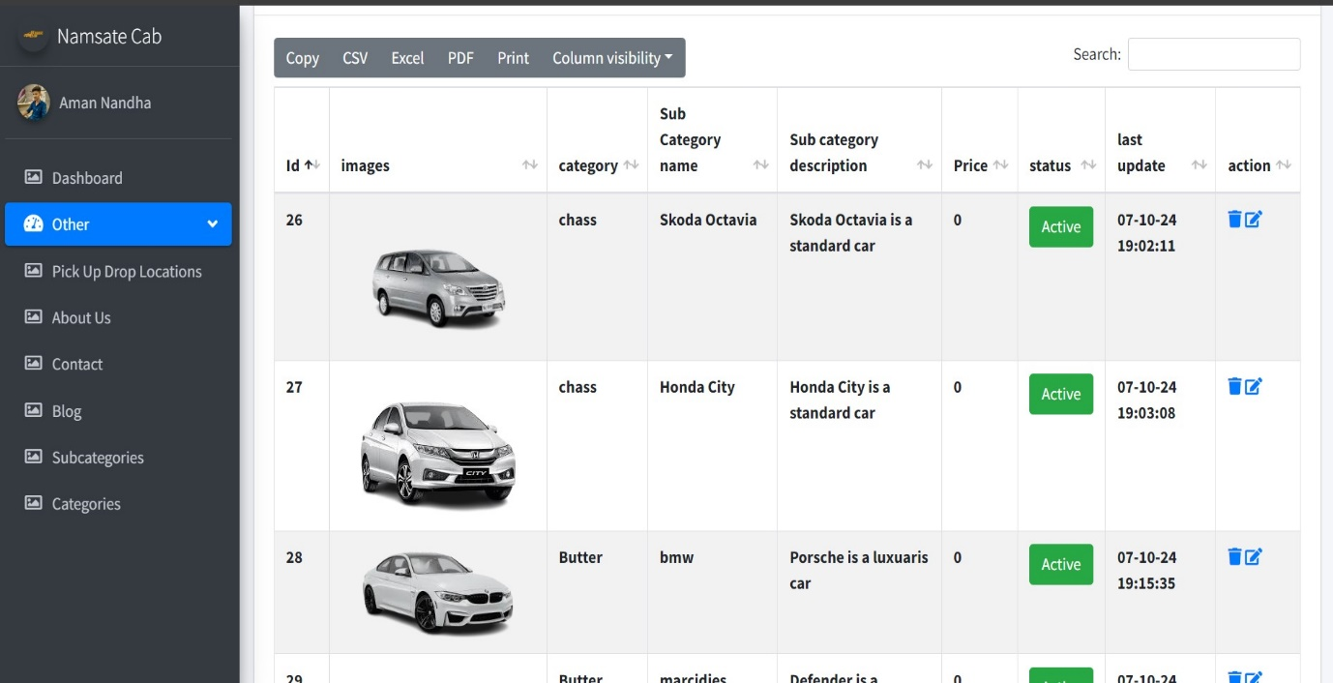

**ADMIN CONTACT SCREEN**

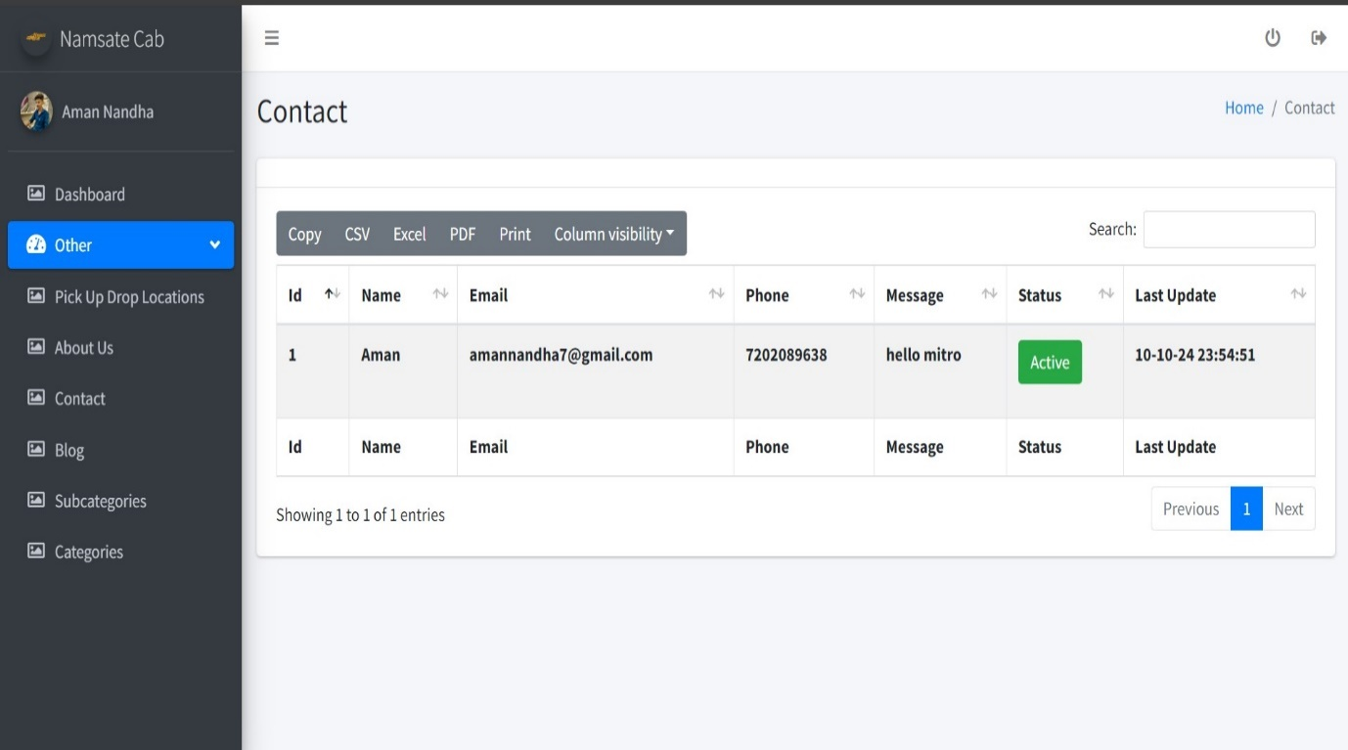

**ADMIN BLOG SCREEN**

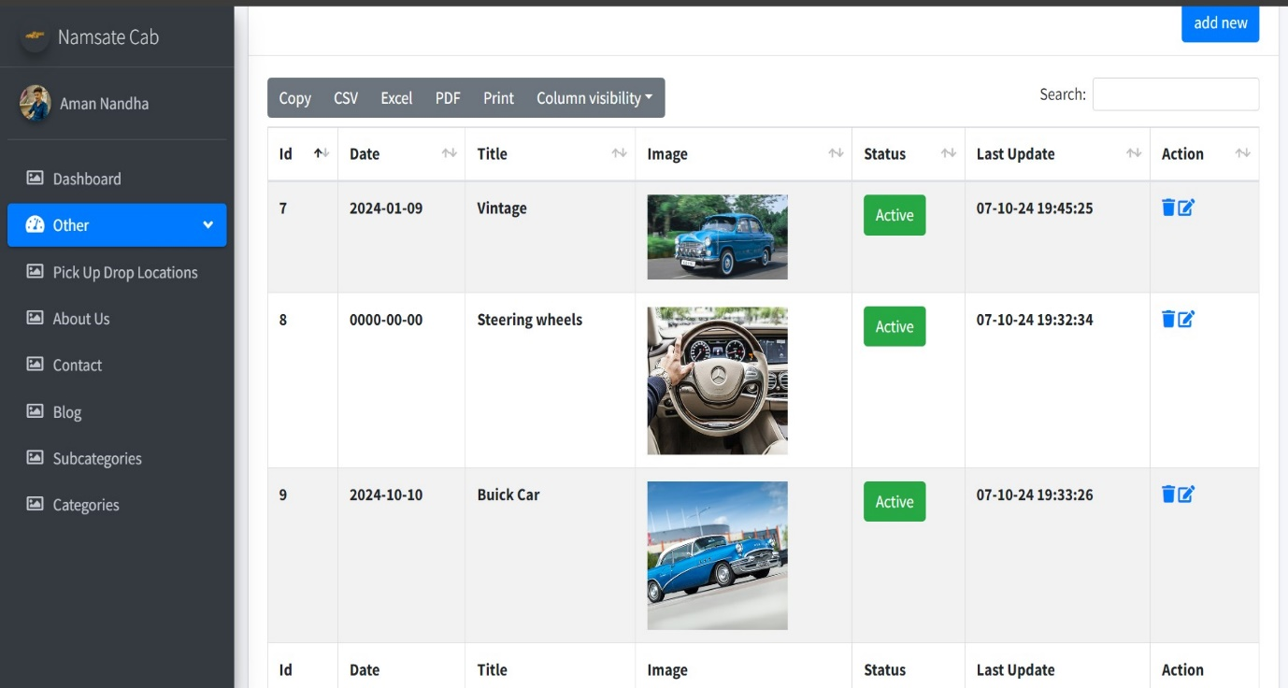

**System testing**

The important and essential part of the system development phase after designing and developing the software is system testing?

We cannot say that every program system is perfect because of task of communication between the user and the designer some error is there in the software development.

This a time, when all the subsystem is gathered into one pool and test whole system to determine whether it meets the user requirement.

Testing is important function to the success of the system.

There are three techniques of software testing:-

**White box testing:**

This type of testing requires the knowledge of internal structure of software (code) which is clearly visible to programmer so it is known as white box testing.

This is also known as glass box, structured, clear box and open box testing.

White box testing is performed by development team /programmer.

**Black box testing:**

This method is named so because the software programmer in the eyes of the tester is like a black box, inside which one cannot see.

It is also called behavioural /function testing.

It is performed by software engineer.

Tester compares real output with the expected output for success of testing process.

**Grey box testing:**

Grey box testing is combination of black box and white box testing.

It is also known as translucent testing.

**Manual testing:**

Manual testing is process which is done manually.

All the famous phases of SDLC like test planning, test deployment, result analysis, test execution, bug tracking and reporting tools are obviously coming under the category of manual testing and done successfully by human efforts.

Manual testing is a start of testing, without this testing we cannot start automation testing.

In manual testing we find more bugs than automation by error guessing.

It takes lot of time.

Manual testing would be run sequentially.

Regression testing process is tough in manual testing.

It is not expensive.

More testers are required in manual testing because in this testing test cases need to be executed manually.

It gives low accuracy result.

It is considered as low quality.

In this testing we cannot do batch testing.

It is considered as less reliable.

No need of programming in manual testing.

It is done without interaction of any tool.

**Automation testing:**

Automation testing is process which is done by the help of automated tools.

In automation testing all the popular phases of SDLC are done by various open sources and purchased tools like selenium, I meter, QTP, load runner, win runner and so on.

Automation testing is continuous part of manual testing.

In automation testing we test the repetitive functionalities of the application.

It takes less time.

It is done on different machines at same time.

Regression testing process is easy in automation testing by tools.

It is expensive.

Few testers are required in automation testing because this testing test cases need to be executed by using automation tools.

It gives high accuracy result.

It is considered as high quality.

In this testing we can do multiple types of batch testing.

It is considered as more reliable.

Need of programming is must in automation testing.

It is always done using tools.

**Advantages & limitations of project: -**

* **Advantages:**
* You can maximum Booking.
* You can book for Cab from your place.
* You’re not tied to a phone.
* Online Cab booking systems mean your business is open 24 hours a day seven days a week.
* Collecting customer information.
* Updating availability after booking has been made.

**Limitations:**

You need internet access. Reliable internet access is required to check reservations and add order that is made over the phone.

You need to be Read for an influx of new customers.

Not all online booking system is created equal.

Booking software recommendation.

If the website is down, you won’t be able to Book it online.

* **Future enhancement**
* Our website provide facilities to improve digital India
* Online Cab Book give some basic and pro benefits
* But what’s about upgradation
* And what’s about future?
* We give more benefits in future
* Like…
* We have no payment facilities in our site
* But in future we give to benefit of the online payment so
* Improving in our site, improving in Security and Services.

**Reference and Bibliography**

**\* Web sites:**

● <http://www.apachefriends.org>

● <http://www.php.net>

● <http://www.mysql.com>

**\* Search engines:**

●Google search engine

●Mozilla Firefox

●Google chrome

**\* References:**

● [www.google.com](http://www.google.com)

● [www.co3school.com](http://www.co3school.com)

● [www.steemit.com](http://www.steemit.com)

**\* Books:**

* Php developer

**Thank You**